Name ___________________ Evolution and Classification Test Review

- Why is a standard classification system necessary?

- List the 8 taxa in order from broadest to narrowest.

- One of the taxa is Kingdom. List the 6 Kingdoms.

- Correctly write the scientific name of a cheetah.

Fill in the blank with the correct Kingdom.

_________________ 5. All contain chloroplasts to aid with photosynthesis.
_________________ 6. Thrive in extreme environmental conditions; primitive
_________________ 7. Have cell walls made of chitin.
_________________ 8. Have cell walls made of cellulose.
_________________ 9. Contain organisms that are plant, fungus, or animal-like.
_________________ 10. Contain cell walls with peptidoglycan.
_________________ 11. Contain multicellular heterotrophs lacking a cell wall.
_________________ 12. This kingdom contains amoebas and paramecium.
_________________ 13. This kingdom contains yeasts.
_________________ 14. Contains organisms that are unicellular eukaryotes.
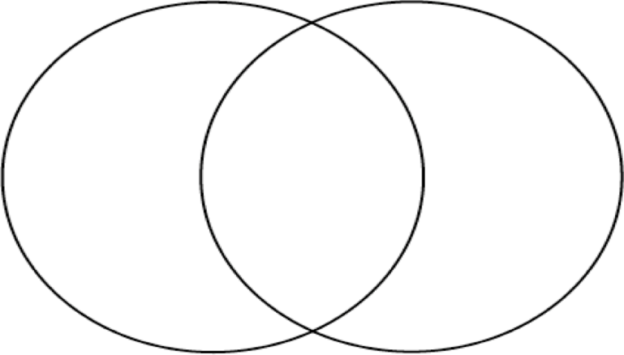
15. Fill in the Venn diagram that illustrates
the similarities and differences between viruses
and bacteria.

16. Describe the events of the lytic and lysogenic cycles below.
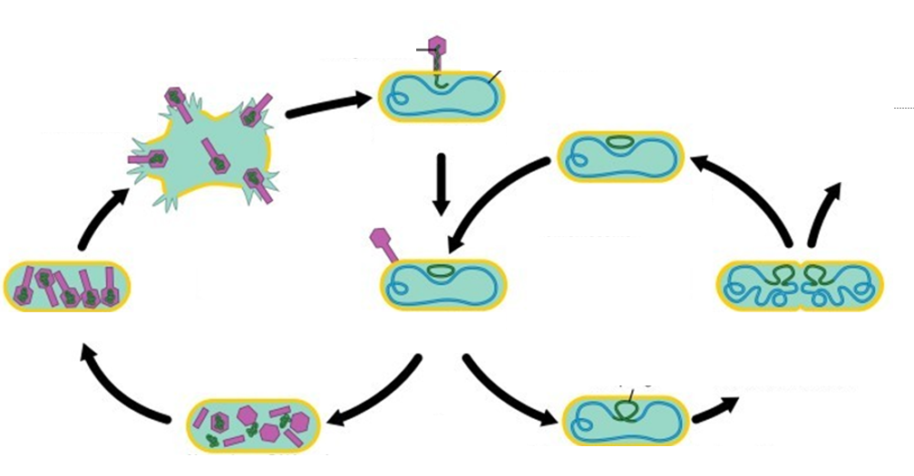

17. Define the following terms:
Evolution

Natural Selection

Fitness

Adaptation

Variation

Common Ancestor

Homologous Structure

Analogous Structure

Vestigial Structure

Taxonomy

Autotroph

Heterotroph

Pathogen

Vaccine

Binomial Nomenclature

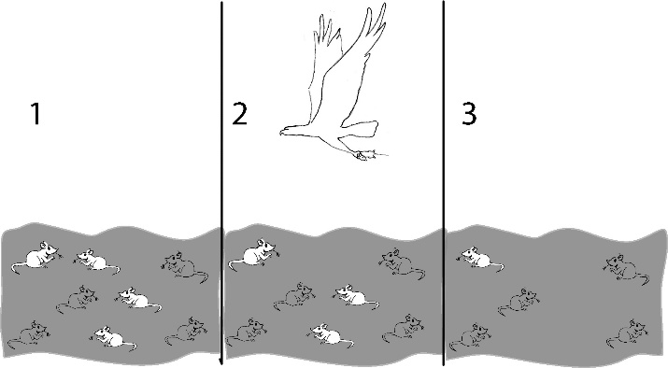
18. Describe what is happening in figures 1-3 to the right. Is the population of mice different in figure 3 than in figure 1? Explain why.

19. Draw and explain the three types of natural selection

20. List and briefly describe the evidence of evolution

A.

B.

C.

D.

E.
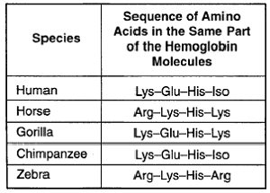
21. The table shows a comparison of some amino acids found in cytochrome c. Which two organisms are most closely related to each other?

22. What is a vestigial structure? Give an example.

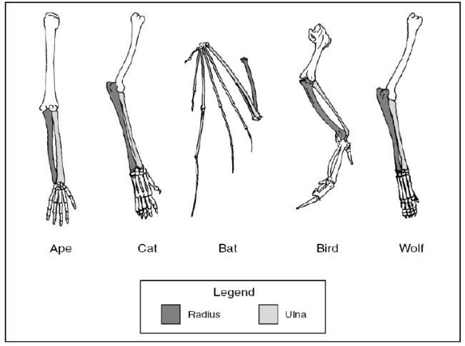
23. The picture to the right shows homologous structures. These structures provide evidence of what?

24. Describe and give an example of Genetic Drift

25. Describe and give an example of Gene Flow

26. Describe and give an example of Artificial Selection

27. Describe and give an example of Sexual Selection

